Group symbol: 3
Team: 1

Project title: Resource Allocation App

Team members (filled by PM, Team Leader):
No | Name | Surname | Student ID | Role
1 | Carmelo Aidan | Romero | 293936 | PM, Team Leader
2 | Álvaro | Puebla | 293867 | Team member
3 | David | Sosa | 293885 | Team member
4 | Diego | Ceballos | 293943 | Team member
5 | Diego | García | 293939 | Team member
6 | Óscar | López | 293871 | Team member

- Design (S3)
  - Logical Software Architecture
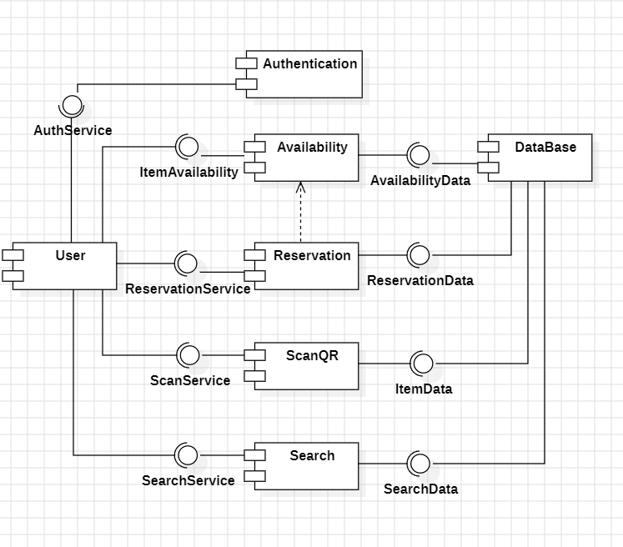
The logical architecture aspect of the system should be present as a Component Diagram expressed in UML 2.5.

  - Business Logic Model
    - Behavioural Model
In this section present:
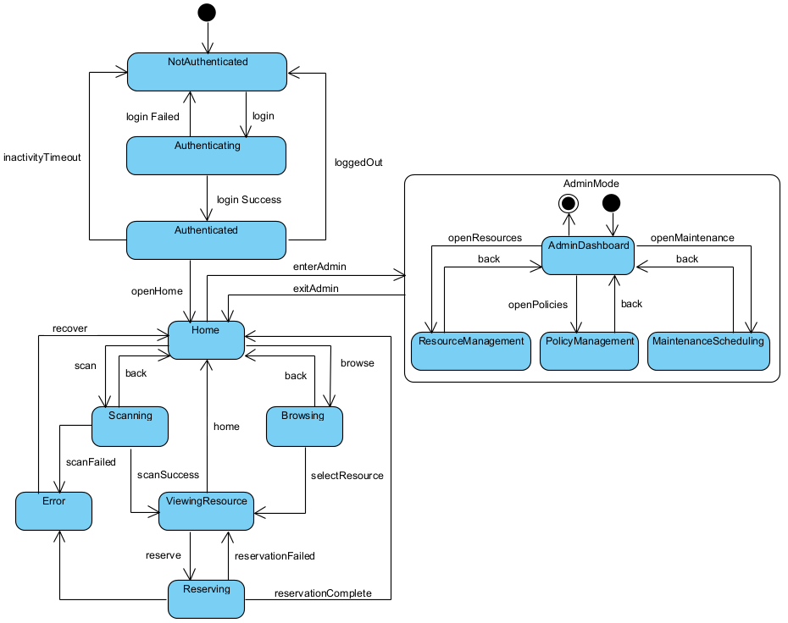
  - state diagram for whole the system and

  - behaviour of 2 crucial use cases using the UML 2.5 diagrams, namely sequence diagram, and activity diagram.
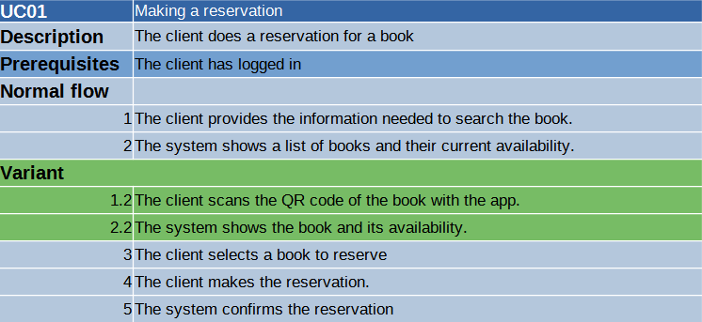
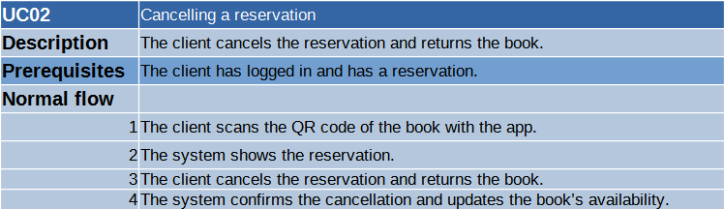

    - Structural Model
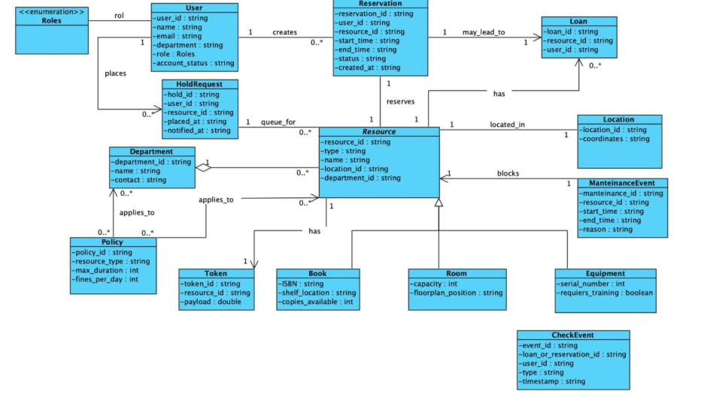
Prepare the model as class diagram expressed in UML 2.5. Use natural language to describe the semantics of models’ elements. Besides, use the object diagram to present an instance of the model at the time of system execution.

  - Database Model
    - Conceptual Model
The model contains the definition of entities and relationships among them in terms of the database (persistence). You should present it as a diagram and description of key elements in natural language.
This model represents a reservation system that manages different kinds of resources and the users who interact with them. It includes two specialization hierarchies and clearly defines how reservations are created, controlled, and stored.
- Entities
User
Represents any person registered in the system.
Key attributes include an identifier, name, contact information, credentials, account creation date, and account status. This entity functions as the parent for two specialized roles: Client and Admin.
Client
A specialized type of user who can make reservations and loans.
Additional attributes define limits on active reservations and loans, the type of client, and an optional date until which the client may be blocked.
Admin
Another specialization of the User entity, representing staff members who oversee the reservation process.
Attributes include an employee code, administrative level, department information, and an indication of whether the account is active.

Resource
Represents any item that can be reserved.
It stores a unique identifier and the availability status. Two subtypes extend this entity: Book and Room.
Book
Specialization of Resource for library items.
It contains descriptive fields such as title, author, ISBN, publication year, and the number of copies available.
Room
Specialization of Resource for reservable spaces.
Includes attributes such as a room code, name, capacity, and physical location.

Reservation
This associative entity captures the act of reserving a resource by a client.
It stores the reservation identifier, date, status, time interval (start and end), and optional notes.
It connects clients and resources and may also be associated with an admin who oversees or approves it.

2. Relationships
Client Reserves Resource
A client can make many reservations, and each resource can be reserved multiple times.
Each reservation entry links one client to one resource and contains the details of that specific reservation.
Admin Controls Reservation
An admin may supervise or manage various reservations.
Each reservation can optionally be associated with one admin, indicating administrative control or approval.
Specialization Hierarchies
- Resource → Book / Room
The system uses inheritance to represent different types of reservable items under a single parent entity.
- User → Client / Admin
This hierarchy separates general user data from role-specific information, ensuring a clear structure for permissions and responsibilities.

3. General Behavior of the System
The model supports:
- Creation, modification, and cancellation of reservations by clients.
- Administrative supervision of reservations, including approval workflows.
- Availability checking for books (copy count) and rooms (time slot).
- User lifecycle management for both clients and admins.
Overall, the model ensures that all reservation-related data is stored consistently while preserving a clear separation between resource types and user roles.
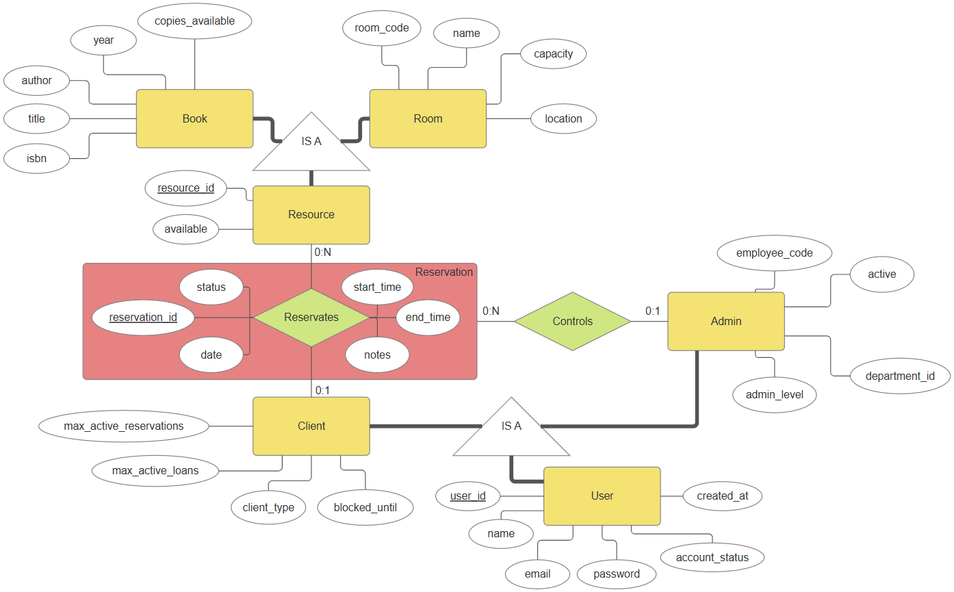

    - Physical Model
The model presented as a diagram of the database that constitutes the implementation of the conceptual model in the selected database management system.
It is required to include an elaboration on the transformation of the conceptual model to the physical model. Description of transformation should include how elements like, e.g. inheritance and associations or other sophisticated modelling concepts have been handled.

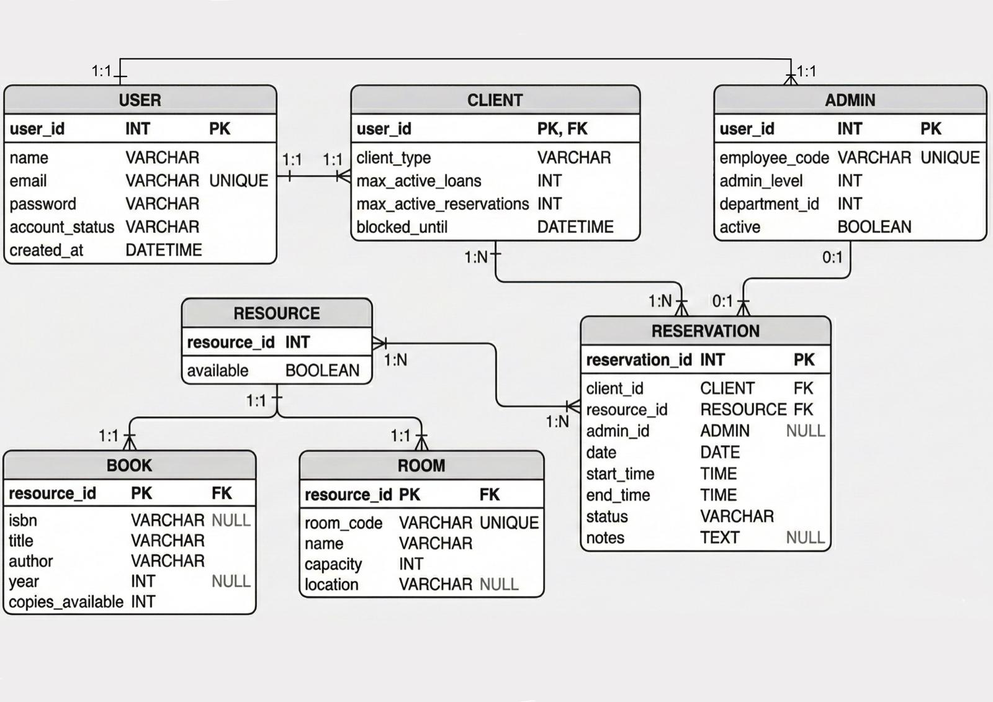

  - User Interface Design
In this section, you should present the distribution of user interface components with events and their assignments to the behaviour specifications, which these elements initiate or take part.
These are the different pages we designed for this project, but we do not discard the fact that we may need to make new ones as the project advances and evolves.
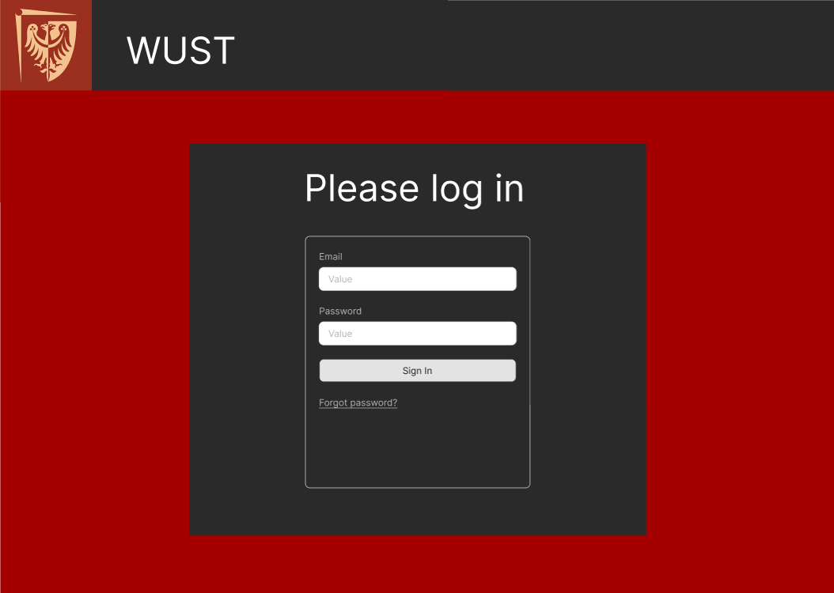
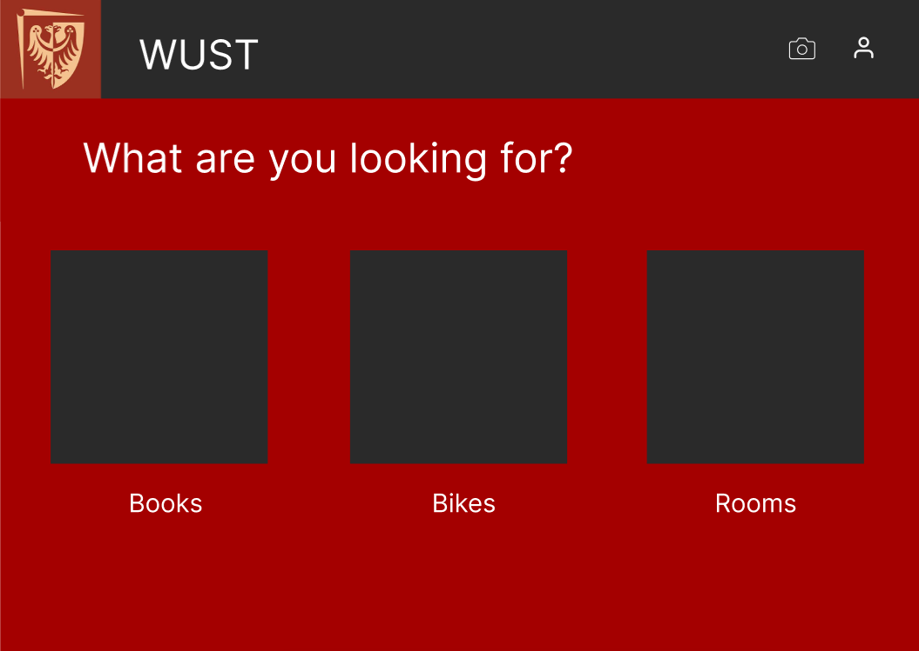
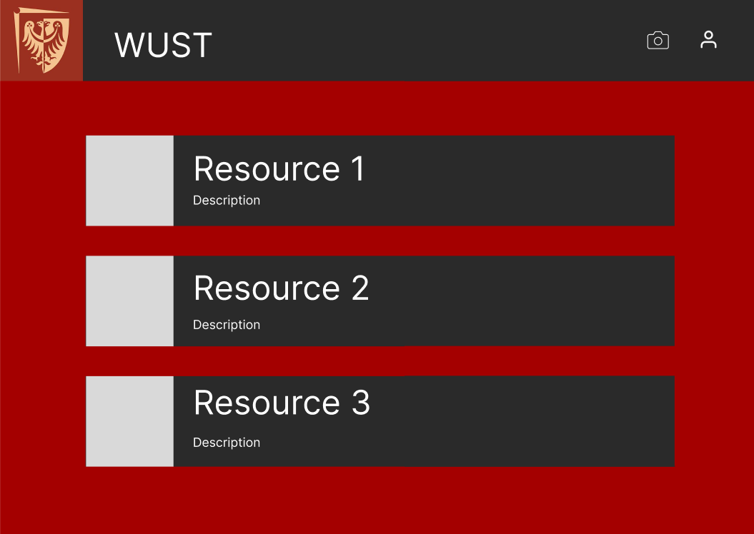
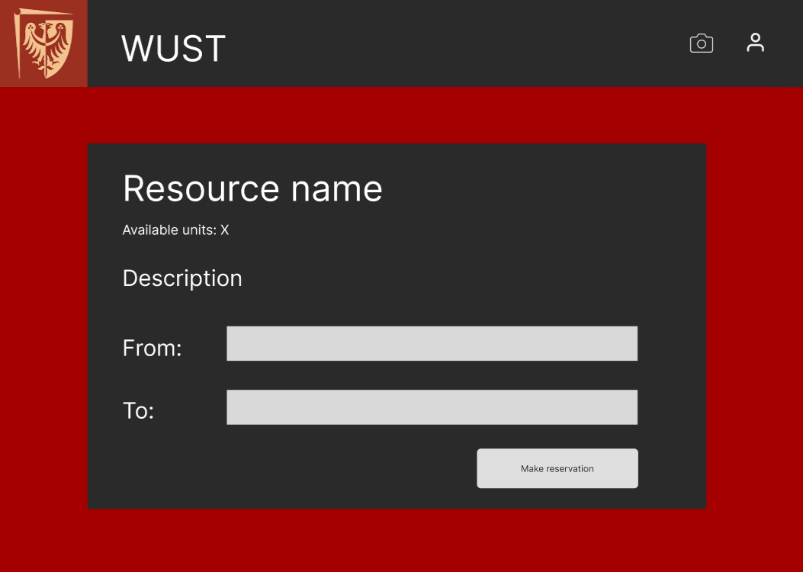

Here is a description of the events that occur when the user interacts with said interface:

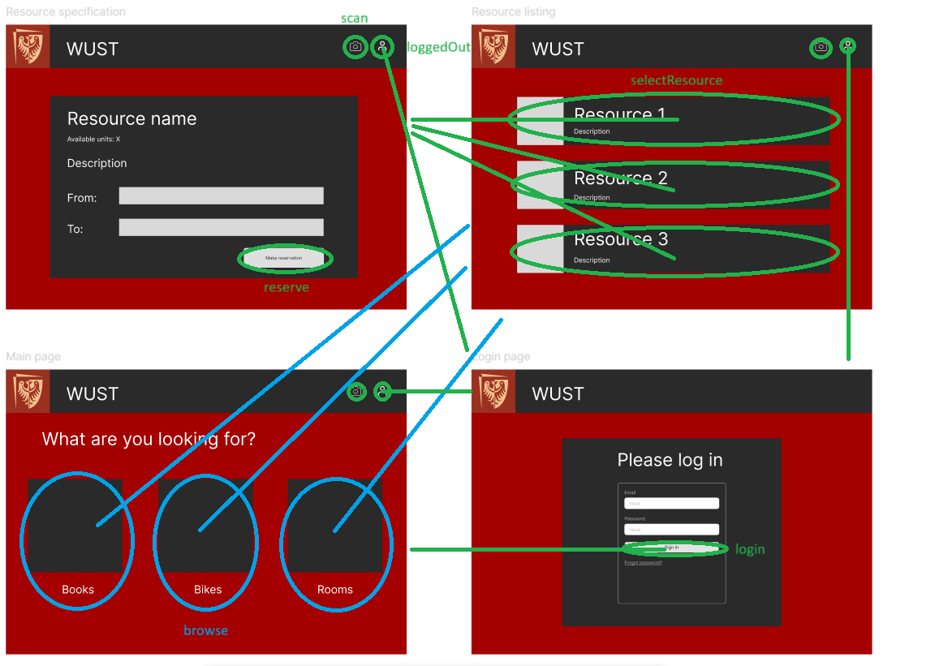
Note: All the events described in this picture are onclick events.

